FIT3179 Week9 Homework

Name: Joshua Tan Meng Yuan

Student ID: 33213992

Lab: 01_OnCampus

Tutor Name: Bruno Luis Mendivez Vasquez

URL: <https://joshuatanmy.github.io/FIT3179-2024/>

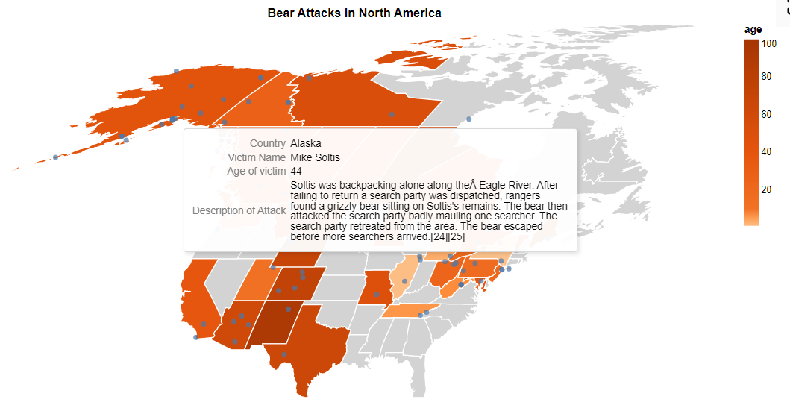

* Domain: The general public in North America to raise awareness about bear attacks and where they occur.
* Dataset: Bear attacks in North America containing the attributes Name, age,gender,Date,Month,Year,Type,Location,Description,Type of bear,Hunter,Grizzly,Hikers,Only one killed,Latitude,Longitude
* No data transformations were applied, the color on the map shows the max age of each attack in that area
* A choropleth map best demonstrates the information about each state in the north America region, the dot map or symbol map would not have been as effective in visualizing the age in each state and the geographical locations of these attacks.